Step 3 – PL/SQL Code

Create OrderDetailsType which will be used in the first function.

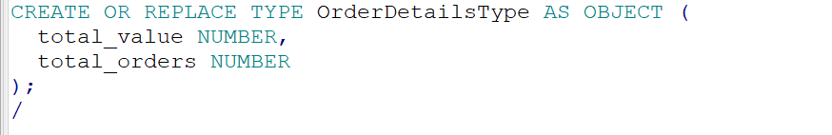

Function 1:

Calculate total orders and total orders values for a customer

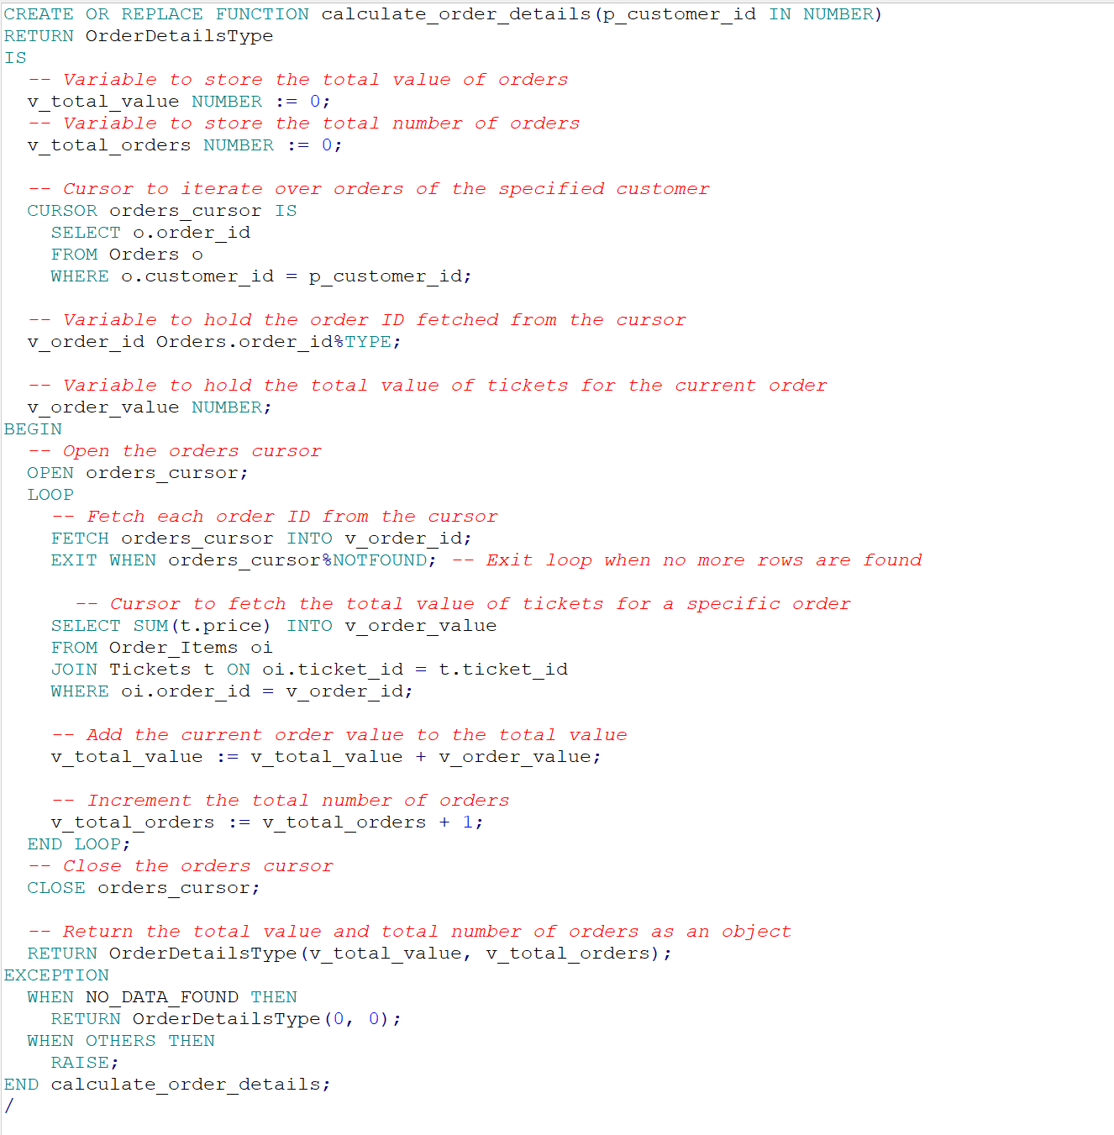

Add discount field to orders table.



Procedure 1:

Receive a customer id and a total orders value and apply 10% discount to all orders if total orders value is higher than 1000.

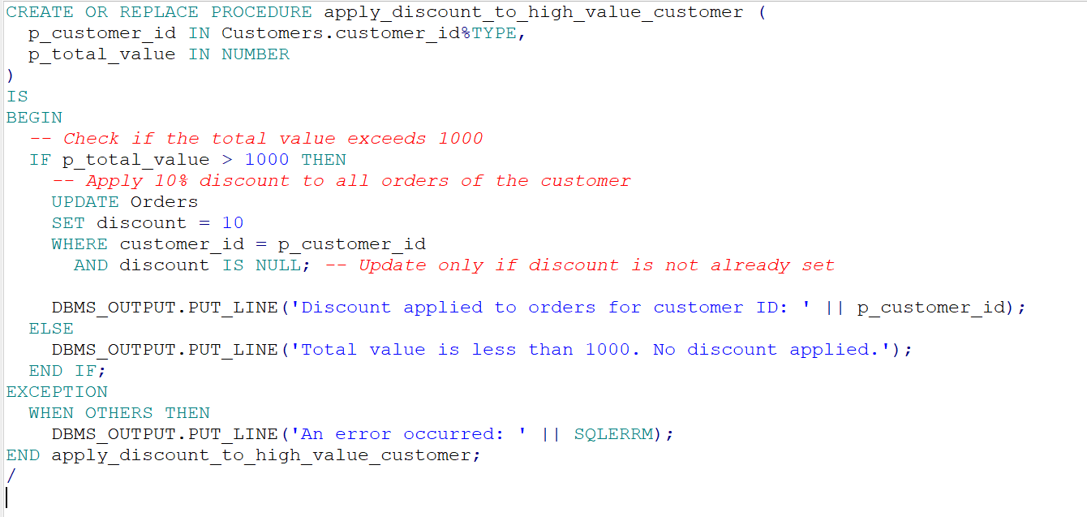

Main program:

A program which receive a customer id as an input, calculates it's total orders value and update each order to get 10% discount.

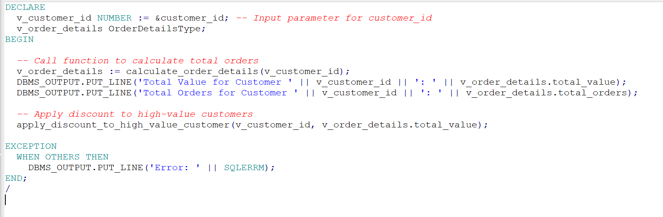

Main program execution.

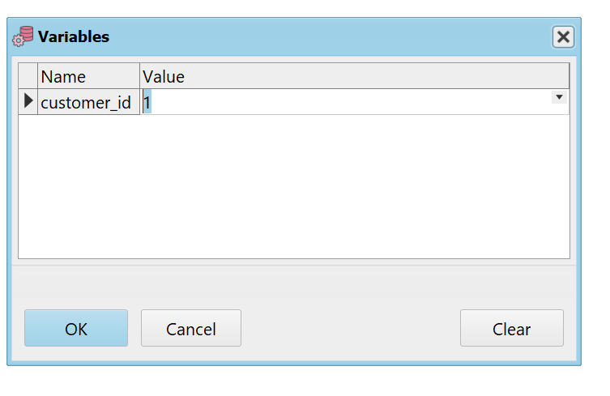

Main program output.

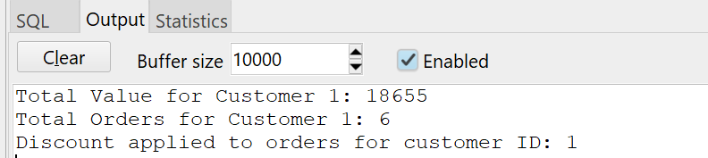

Customer id 1 orders have been updated and 10 discount applied.

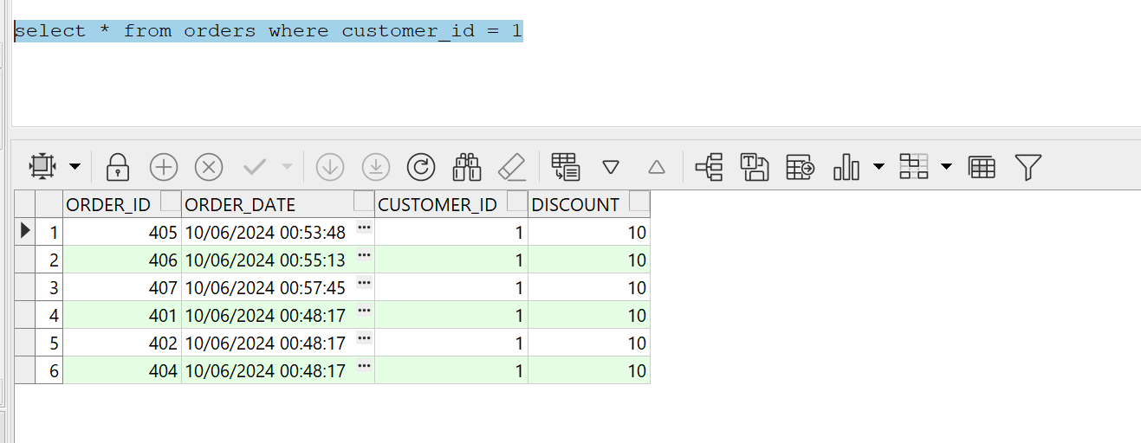

Function 2:

Analyze attractions revenue by area.

Present a report displaying four categories:

Revenue > 1000

Revenue between 500 to 1000

Revenue between 100 to 500

Low revenue

The function receives an area id and returns the revenue analysis according to this area.

By default, the function returns analysis for all revenues.

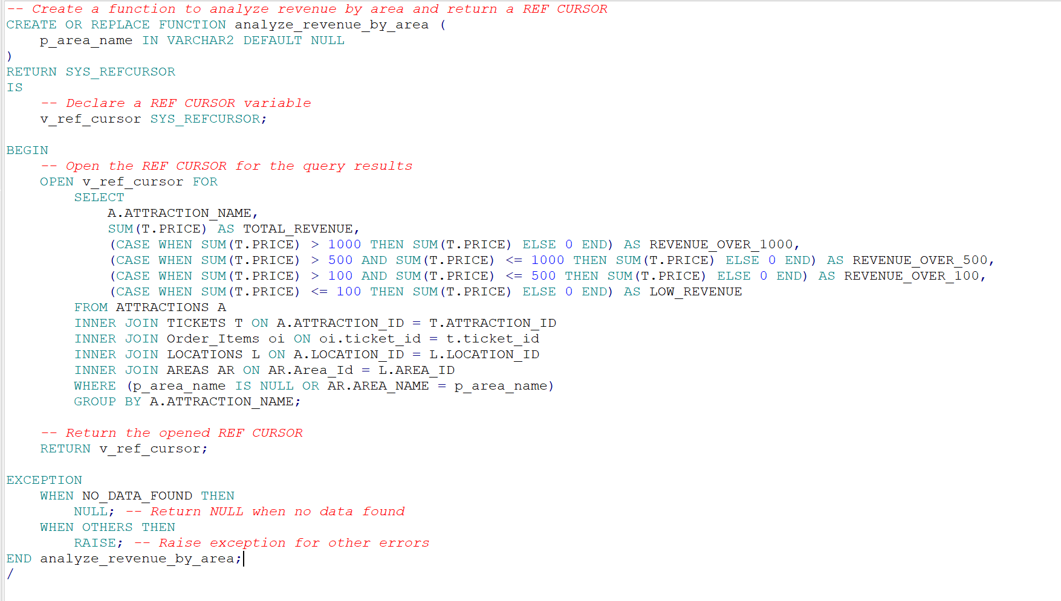

Procedure 2:

Calculate total revenue for attraction.

The procedure receives an attraction name and calculates it's revenue.

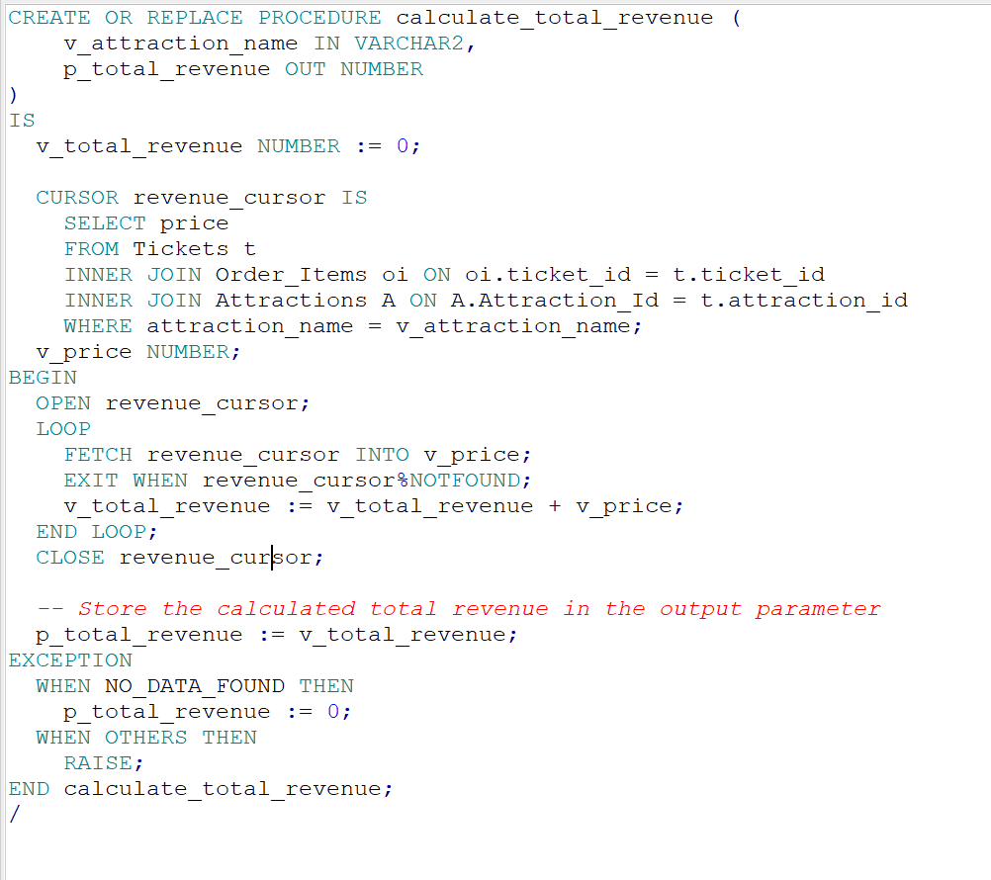

Main program:

The program receives an attraction name and area and then print the attraction revenue and a table with all revenues according to this area.

Eventually, the program presents the total count of attractions with high revenue.

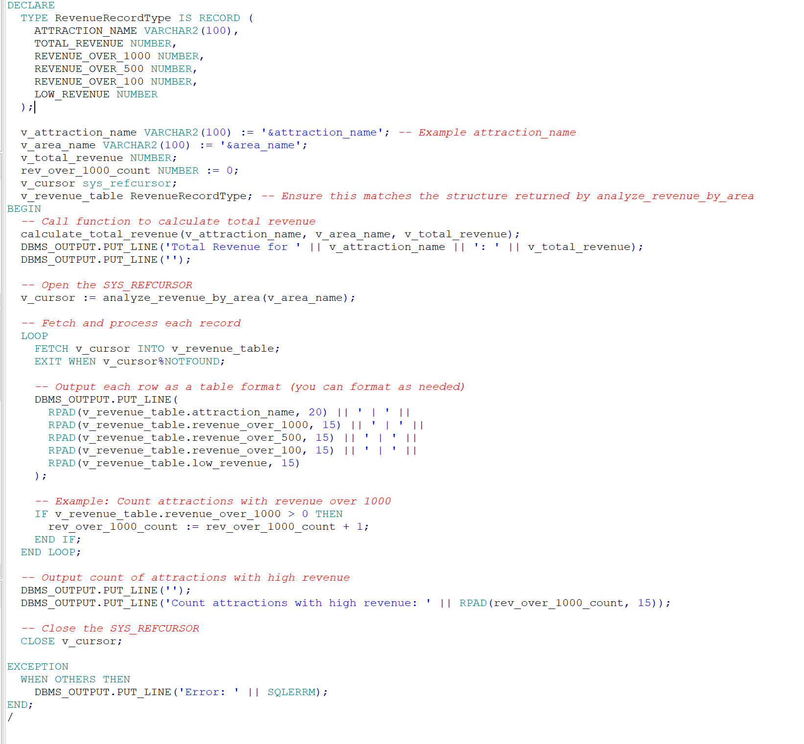

Main program execution:

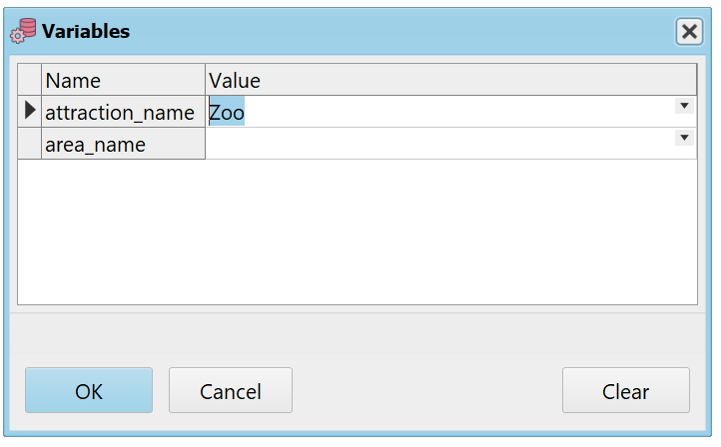

Default – no area selected.

Output:

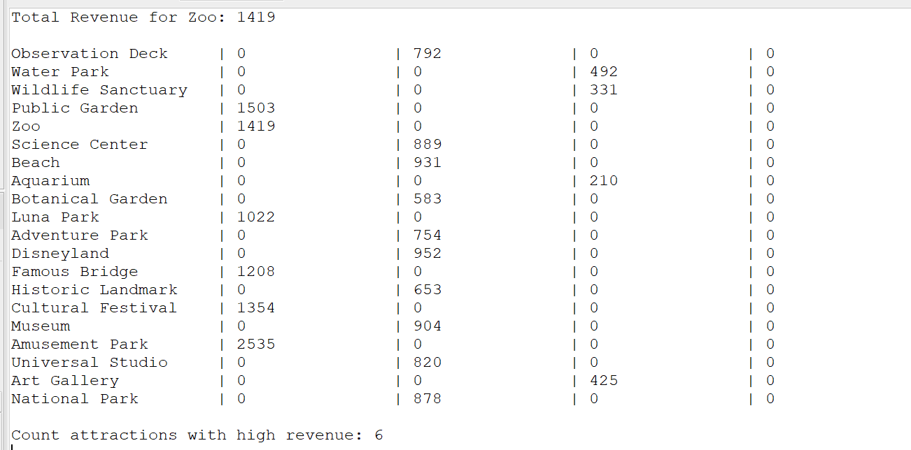

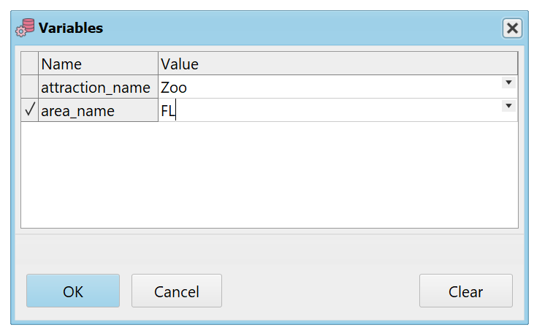

Select FL area.

Output:

